

Monthly Newsletter
Corporal Johnny A. Williamson Detachment #1165

Marine Corps League - Asheboro, N.C.
July 2017 – November 2017
Our Next MCL Meeting Date: Tuesday July 18th

Detachment Officers 2017-2018

Commandant--------------------------- Harvey L. Allred
Phone: 336-629-8132
Cell: 336-460-0421
e-mail: hallred56@triad.rr.com
Senior Vice Commandant ------------ Danny R. Wood
Phone: 336-672-2865
Cell: 336-301-2299
e-mail: dwood@dmp-inc.com
Jr. Vice Commandant--Charles Zimmerman (Chuck)
Phone: 336-431-8964
e-mail: chuckieboy90@yahoo.com
Judge Advocate --------------James F. Stephens (Pete)
Phone: 336-685-9898
e-mail: bpstephens64@bellsouth.net
Adjutant ---------------------------- William Petty (Bill)
Phone: 336-889-7817
Cell: 336-953-3537
e-mail : tag1195@yahoo.com
Paymaster ------------------------ D. Filmore York (Fil)
Phone: 336-622-2121
Cell: 336-212-0223
e-mail: fyork@triad.rr.com
Chaplain -----------------------James R. Williams (Ron)
Phone: 336-625-9898
Cell: 336-963-3965
e-mail: nchp611@aol.com

Sergeant at Arms ----------------- Gary Q. Caviness
Phone: 336-879-3132
e-mail: garyandphyllis@rtmc.net
Historian -------------------------------- H. Carlton Cheek
Phone: 336-629-1049
e-mail : onehoursherry@triad.rr.com
Photographer --------------------------------- Steve Sugg
Phone: 336-879-4017
e-mail: sasugg@rtmc.net
Past Commandant -------------------- Danny R. Wood
2016-2017 Phone: 336-672-2865
Cell: 336-301-2299
e-mail: dwood@dmp-inc.com
Nonperishable food items can be brought each month to be taken to the Christians United Outreach Center. 135 Sunset Avenue, Asheboro N.C. 27204
www.cuoc.org (336)-625-1500

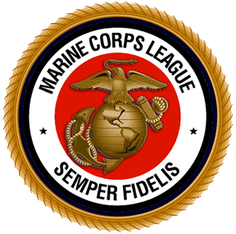
Upcoming Events
MCL Meeting : If You Come We Will Feed You! Between 1815 -1900 Dinner will be served at our monthly meetings. The Meal for June will be a Surprise Meal provided by our Detachment. Come join us for the camaraderie with your fellow Marines. The meeting will begin around 1900 and conclude NLT 2000.
July 2017
Independence Day Tuesday 4th
Detachment Meeting – Tuesday 18th
Social Hour / Dinner – 1800 Meeting 1900
American Legion Post 45, Lanier Avenue
August 2017
Detachment Meeting – Tuesday 15th
Social Hour / Dinner – 1800 Meeting 1900
American Legion Post 45, Lanier Avenue
September 2017
Labor Day Monday 4th
Detachment Meeting – Tuesday 19th
Social Hour / Dinner – 1800 Meeting 1900
American Legion Post 45, Lanier Avenue
October 2017
Detachment Meeting – Tuesday 17th
Social Hour / Dinner – 1800 Meeting 1900
American Legion Post 45, Lanier Avenue
November 2016
Detachment Birthday Ball - Friday 10th
Veteran's Day Parade - Saturday 11th
Detachment Meeting – Tuesday 21st
Social Hour / Dinner – 1800 Meeting 1900
American Legion Post 45, Lanier Avenue
Our MCL Covers are Also Available
Only $40.00 each with anodized brass EGA
Point of Contact (POC): Harvey Allred
Our MCL Polo Style Shirts are Available
Only $30.00 S-XL add $1.00 for each X Larger Size
In Colors : Dill Green, Red, Burgundy and Navy Blue
Long Sleeve shirts are also available only $35.00 S-XL
T-Shirts all colors $14.00, $16.00, $18.00 Embroidered
Long Sleeve T-Shirts all colors $18.00, $20.00, $22.00
Point of Contact ( POC ): Harvey Allred
This is your Newsletter, If there is anything You would like to add for next month let me know ASAP!

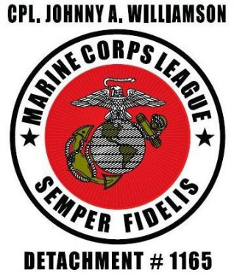
Members & Guest in Attendance on June 20th.
Bill Husband Ken Jalbert
Bill Petty Larry Beane
Chuck Zimmerman Mitchell Davis Danny Wood Pete Stephens
Fil York Raymond Hoover
Gary Caviness Ron Williams
Harvey Allred Steve Sugg
Wally Waldridge
Associate Members Elizabeth Nault, Kayte Wiggington & Zoe Faircloth. Evening Guest Priscilla Williams
Welcome New Members Greg Callicutt & Terrence Parson

Congratulations This Month!!
Birthday’s and Wedding Anniversary’s
David Arthur 1st Mike & Cindy Ingold 6th
Doug Smith 5th Jed & Cortney Frye 14th
Mike Ingold 5th Wally & Eva Waldridge 21st
Gary Caviness 6th Ron & Priscilla Williams 27th
Chuck Zimmerman 10th Bill & Janice Pasco 29th
Mike Wilkes 30th

Receive Your Newsletter By E-mail
The newsletter is available by e-mail. Receiving the newsletter electronically is more economical as it saves the price of postage and paper. If you would like your newsletter e-mailed to you, send an e-mail request to the Newsletter editor: hallred56@triad.rr.com



Our Detachment World War II Era Veteran's
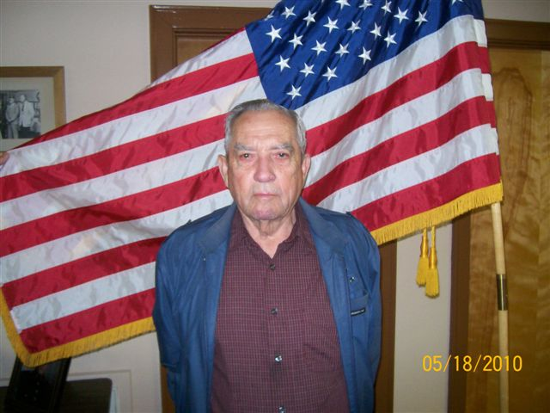
Charles Husband Sr. ( Bill )
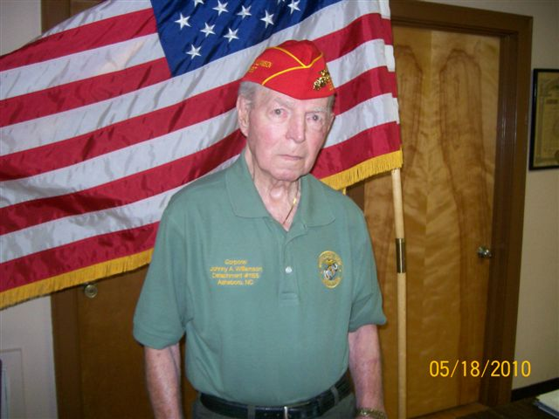
Charles R. Nault
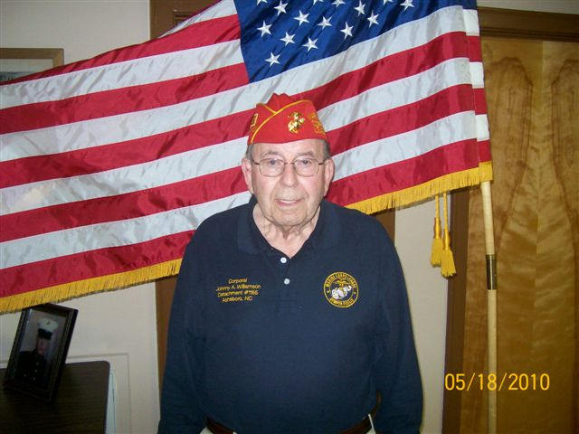
George F. Smith
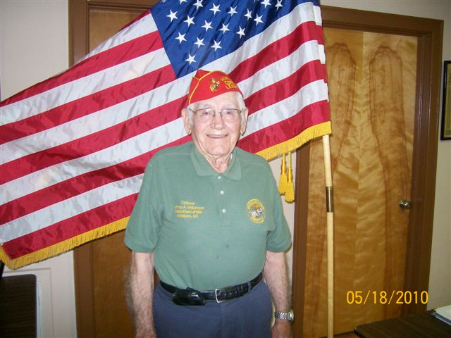
John Coltrane ( Roy )
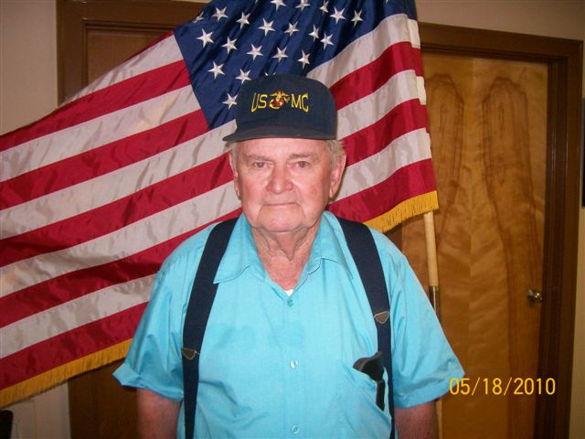
Richard J. Parks
Picture Not Available: Claude L. Coltrane and Clifford Harris
“ Marines “ Thank You for Your Service

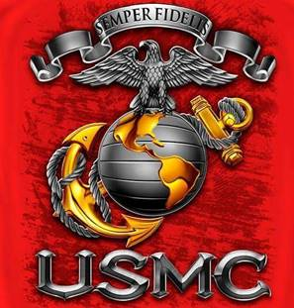

Form 214’s and Personnel Records
Request must include: the Marines full name, SSN, Service number ( if applicable ). Branch of Service, Date of Service, type of information needed (e.g. DD214 or list of awards)
mailing address, daytime phone number and the veteran’s or next-of-kin’s signature. Marines are entitled to one replacement set of awards.
DD 214’s Marines who have been discharged, separated or retired before December 31, 1998 :

National Personnel Records Center
Military Personnel Records
9700 Page Ave., St. Louis, Mo 63132-5100
Phone (314)801-0800, fax (314) 801-9195

Visit: www.archives.gov/veterans/evetrecs/
To initiate an online a DD 214 request. Print a copy of the form, sign it and either fax or mail to the NPRC. Note: Only Marines or next-of-kin should use the online capability.

DD 214’s Marines who have been discharged, separated or retired after January 1, 1999 :

Commandant of the Marine Corps (MMSB-12)
2008 Elliot Road, Quantico, Va 22134-5030
1-800-268-3710, fax (703)784-5792 or 3920

Medical Records. Marines who have been discharged, separated or retired May 1, 1994 or later :

Department of Veterans Affairs
Records Management Center
P.O. Box 5020, St. Louis Mo 63115-8950
Phone (314)538-4500, fax (314)538-4571

Note: Discharged, separated or retired Marines before
May 1, 1994 must contact NPRC

Awards : Marines who have been discharged, separated or retired before December 31, 1998 :

Navy Personnel Command ( PERS-312D2)
9700 Page Ave, Rm 5409, St. Louis Mo 63132

Marines who have been discharged, separated or retired after January 1, 1999

Commandant of the Marine Corps (MMMA)
3280 Russell Road, Quantico, Va 22134

Any Questions: 1-800-336-4649

Veteran’s Issues

Request Copies of Military Personnel Records
US Department of Veterans Affairs Benefit Information Contacts

VA Home Page
www.va.gov

Compensation & Pension
www.vba.gov

Burial & Memorial Benefits
www.cem.va.gov

National Personal Records
www.archives.gov

Arlington National Cemetery
www.arlingtoncemetery.org

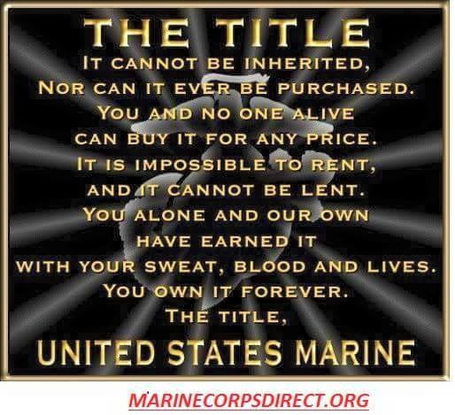

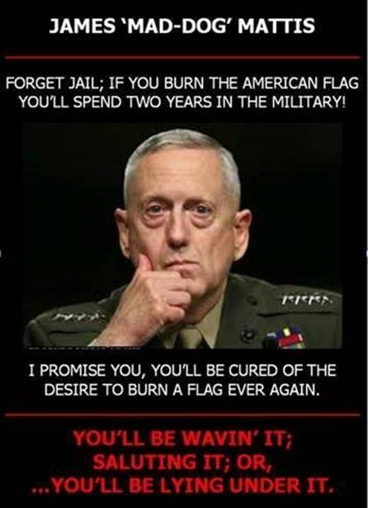

USMC Funeral Honors
The Headquarters Marine Corps, Funeral Honors Section assists the family of deceased service members in arranging military funeral honors for their loved one. The service member must have served in, or with, the Marine Corps and have been discharged under honorable conditions. Funeral directors making requests for military honors must notify the Casualty Branch by telephone with the service members complete name; social security number; rank; status, i.e. retired or former Marine; date of birth; date of death; and place of death (city and state). If a funeral director is unable to obtain a copy of the service members Certificate of Discharge from Active Duty (DD Form 214) or verification of service from the family member, they may request the form from the National Personnel Records Center, St. Louis, MO. The telephone number is (314) 538-3154. The fax number is (314) 538-3115.
The Personnel Records Center requires the use of the Military Records Request form (Standard Form 180) for requests of this nature. This form is available through the National Archives website. If a Standard Form 180 is not available, the National Personnel Records Center will require the service member's name, social security number and/or service number, rank, date of member birth and dates of service.
Family members are encouraged to provide the funeral director with a copy of the service members DD Form 214 to ensure military funeral arrangements are reserved.
Military Funeral Honors Section
3280 Russell Road
Quantico, VA 22134-5102
Comm: (703) 432-9524
DSN: 378-9524
Toll Free: (866) 826-3628
funeral.honors@usmc.mil

Happy 4th of July! The fourth of July is upon us, a holiday that signifies a meaningful moment in U.S. history, a date that marks our official independence as a nation. Over time, freedom and independence have come to take on very deep meaning for everyone.

“They sacrifice more than what we could ever imagine, they answer a call that many of us ignore, but because of them, the US military, we are able to enjoy our everyday life. They don't ask for much, just to be supported and not forgotten.”
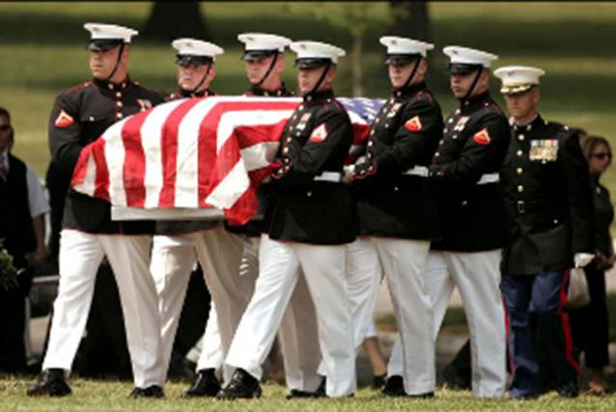
LCpl Jacob Levy

Did you know? When the Armed Services Blood Program (ASBP) cannot collect enough blood, the military must purchase products from civilian agencies, such as the Red Cross (assuming that blood is available for purchase). The average cost of blood from outside sources is about $250 per unit. THEY SHOULDN’T HAVE TO PAY MORE THAN THEY ALREADY DO IN SERVICE.

Since 1962, the Armed Services Blood Program (ASBP) has served as the sole provider of blood for the United States military. As a tri-service organization, the ASBP collects, processes, stores and distributes blood and blood products to Soldiers, Sailors, Airmen, Marines and their families worldwide. As with any blood collection agency, their mission is to make sure that they are collecting donors, but very distinct from their civilian counterparts. This program is devoted to the military services. So, the blood they collect is devoted totally for Department of Defense use, whether that’s the warfighters who are deployed or their service families, overseas or not. So, the distinction there is that the civilian community, of course, has to support our community hospitals, etc., but the Armed Services Blood Program is really there for the warfighter and his or her family.

To register to donate blood on October 10th: https://www.militarydonor.com/index.cfm?group=op&expand=77247&zc=27205

If there are any questions about deferral criteria, you can go to the website at www.militaryblood.dod.mil and there’s a link on becoming a blood donor that lists out possible reasons that you could get deferred.

Medication list: http://pathology.ucla.edu/workfiles/Education/Transfusion%20Medicine/Armed-Services-Medication-List.pdf
Medical condition list: http://www.militaryblood.dod.mil/About/doc/ASBP_Medical_Conditions_List.pdf

Amanda W. Varner, NCCCC
Clerk to Randolph County Board of Commissioners
Administrative Assistant to the County Manager
725 McDowell Rd.
Asheboro, NC 27205
336-318-6301
336-318-6853 Fax

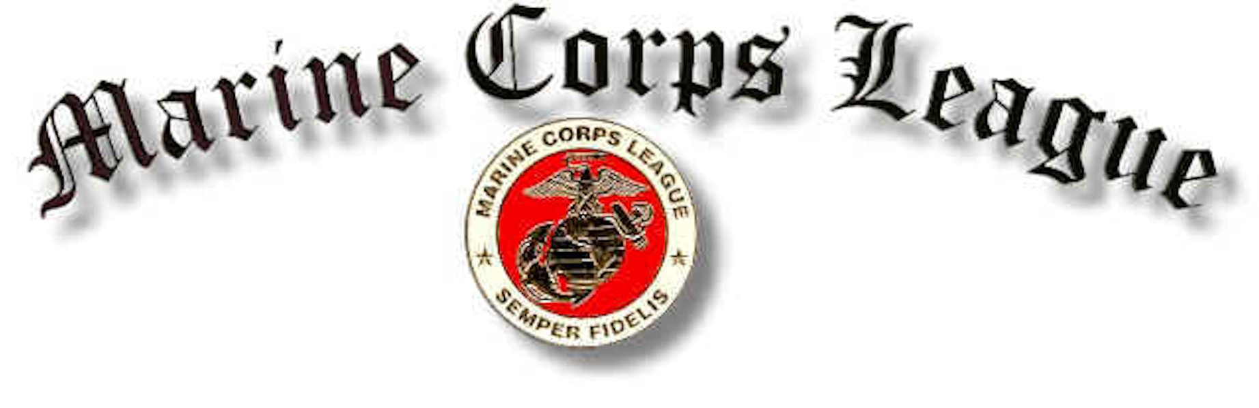
Corporal Johnny A. Williamson Detachment #1165

Marine Corps League Monthly Meeting Held June 20, 2017
At the American Legion Post 45 Asheboro, N.C.

There were a total of 19 in attendance 14 members, 3 associate members and 2 guests.

Commandant Harvey Allred, called the meeting to order at 1900 hours.

Sergeant at Arms Cary Caviness opened the meeting with everyone saying The Pledge of Allegiance while saluting our flag.

Chaplain Ron Williams gave the opening prayer.

Commandant Harvey Allred called for Sergeant at Arms to secure quarters.

Sergeant at Arms declared the meeting open for business. Harvey asked for the roll call of officers present.

- Senior Vice Commandant – Danny Wood _ Present
- Junior Vice – Chuck Zimmerman _Present
- Judge Advocate – Pete Stephens -Present
- Adjutant – Bill Petty _ Present
- Paymaster – Filmore York _Present
- Chaplain – _Ron Williams_ Present
- Sgt-at-Arms – Gary Caviness _ Present

Introduction of Guests
Ron William’s wife Pricilla and Terrence Parson
Terrence said he was married and lives in Randleman and has 5 kids from age 30 to 8. He said that he coaches basketball, baseball, and football and that he works for Guilford County as a carpenter.

Application for membership
Greg Callicutt and Terrence Parson were voted on and approved by all members present to become our newest members.
Fil said that Steve Sugg paid his last payment for his life membership.

Members or Family Members Sick or in Distress
Fil said that Roy Coltrane fell again and either he dislocated it or broke it and they did a hip replacement. He is now at White Stone Masonic in Greensboro and he was doing very well.
Ron Williams said that if he could get an address he would send him a card.
Harvey asked if anybody was going to visit Roy to let him know and he would let them take one of our Marine Corps blanket to Roy, Fil said that he would probably go so he would take him one.
Fil said that Roy was on the second landing at Iwo Jima and was wounded and the corpsman that tended to him was killed so it was never documented, so he never received a Purple Heart. Fil said that he had been working with Congressman Walker and Thom Tillis to try and get the Purple Heart as soon as possible.
Harvey said that Roy had just turned 95 on the 11^{th.}
Larry Beane said that his wife’s brother Mike Hamlin had stage 4 cancer and was not doing well.
Wally said that his wife Eva was starting a new treatment for her cancer and that her doctor seemed upbeat about it.
Kayte said that her cardiologist had released her now she could go back to normal.

Report of Officers
Fil said that he had to redeposit our check to Wounded Warriors that was returned to him. He said that he was contacted by Craig Stevens command advisor for Wounded Warrior Battalion East and he gave him four no profit organizations that we might consider sending our donations to in the future. The names are Hope for the Warriors, Semper Fi Fund, Fisher House Foundation, and USO in Jacksonville N.C. Fil said that he had contacted all of these organizations and they were to send him information.
Harvey said that he talked to the folks at the American Legion about the condition and quantity of our tables. They told him that they were going to buy new ones, but didn’t say when.
Harvey spoke about the Memorial Day service and thanked Lucky for putting it together. He said that this year the Veterans Council decided to have 1 person from each branch of service to help with the burning of the names.

Harvey thanked everybody that came out to Oaklawn Cemetery to put out flags for Memorial Day and for the ones that showed up to retrieve them.

Gary said that he noticed that there were a lot of flags that needed to be replaced.

Harvey said that we should check the flags before they were put out on Veterans Day and that he was going to get a new container for the flags.

Steve Sugg asked if we had found any better Marine Corps flags and I have looked on the internet, haven’t found anything any better yet.

Harvey asked if anyone found any to let him know.
Harvey asked if anyone wanted to help with the fall festival this year and we should vote on it at the July meeting.

I said that if we did the fall festival that we need our own tent and I volunteered to check prices and bring them to the next meeting.

Larry Beane said that his wife Becky is retiring and that they have purchased a home in Leesburg Florida and will be moving there soon. He said that he would try and visit if possible and that he was going to miss everybody.

Ron Williams said that his son Air Force Major Jason Williams has been selected to be promoted to Lieutenant Colonel. Ron said now his son finally out ranks him, when he was Air Force O4 that was equal to E4 in Marine Corps so now he out ranks him.

Fil said that we have all new Department Officers now and maybe the problems in the past will go away.

Announcements for the good of the League
Harvey said that we got a thank you card from the Staley Baptist Church for Richard Park’s wife Almetta for the donation to the church in her memory.
We also received a thank you card for the donation to the SPCA in the memory of Mac McKay.
Harvey said 41 years to the day on June 20 was the day that he stepped on the yellow footprints on Parris Island SC.

Harvey closed the meeting with the singing of the 1st verse of the Marines Hymn.

Commandant asked Sergeant at Arms to lead us in the hand salute of our National Colors.

Chaplain Ron Williams gave the closing prayer.

Senior Vice Commandant Danny Wood preformed his last duty of the day.

Sergeant at Arms Gary Caviness declared this meeting closed until our next meeting on July 18th 2017

50/50 winner was Bill Husband and He donated all 39.00 to the league.

Respectfully submitted this day of July 18, 2017

Adjutant______________________________________________
Bill Petty

Accepted by Commandant________________________________
Harvey Allred



